**ARUNACHALA COLLEGE OF ENGINEERING FOR WOMEN**

**DEPARTMENT OF COMPUTER SCIENCE AND ENGINEERING**

**CUSTOMER CARE REGISTRY**

# SOLUTION ARCHITECTURE

|  |  |
| --- | --- |
| **DATE** | 1 November 2022 |
| **TEAM ID** | PNT2022TMID34000 |
| **PRIJECT NAME** | Customer Care Registry |

**PROJECT PLANNING PHASE - 1**

## SOLUTION ARCHITECTURE

**SOLUTION ARCHITECTURE:**

A solution architecture (SA) is an architectural description of a specific solution. SAs combine guidance from different enterprise architecture viewpoints (business, information and technical), as well as from the enterprise solution architecture (ESA).

**KEY FEATURES OF SOLUTION ARCHITECTURE:**

## Solution Architect: Processes, Role Description, Responsibilities, and Certifications

* Matching solutions with the corporate environment.
* Meeting the requirements of all stakeholders.
* Accounting for project constraints.
* Selecting the project technology stack.
* Compliance with non-functional requirements.

## SOLUTION ARCHITECTURE DIAGRAM: [Customer Care Registry]

Based on the complexity of the deployment, a solution architecture diagram may actually be a set of diagrams documenting various levels of the architecture. The diagram relates the information that you gather on the environment to both physical and logical choices for your architecture in an easily understood manner.

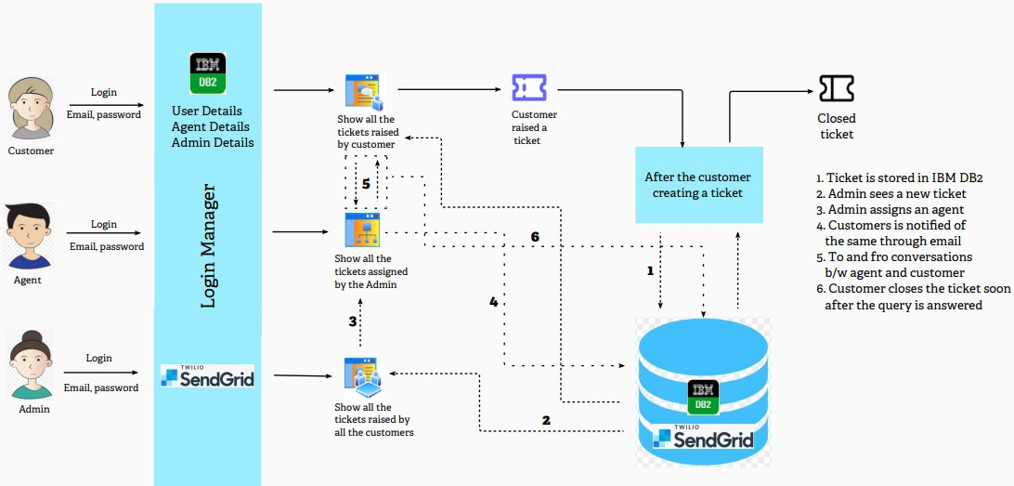

**TECHNICAL ARCHITECTURE:**

